**TECHNICAL DATA**

|  |  |
| --- | --- |
| Height in | 12.7 " |
| Length in | 14.9 " |
| Weight | 6.8 lb |
| Width in | 3.7 " |
| Works With | GNH15G125GV, 1-1/4" 34° 15 ga Finish Nails - Galvanized, GNH15G150GV, 1-1/2" 34° 15 ga Finish Nails - Galvanized, GNH15G175GV, 1-3/4" 34° 15 ga Finish Nails - Galvanized, GNH15G200GC, 2" 34° 15 ga Finish Nails - Galvanized, GNH15G225GV, 2-1/4" 34° 15 ga Finish Nails - Galvanized, GNH15G250GV, 2-1/2" 34° 15 ga Finish Nails - Galvanized, GNH15G125SS, 1-1/2" 34° 15 ga Finish Nails - Stainless Steel, GNH15G200SS, 2" 34° 15 ga Finish Nails - Stainless Steel, GNH15G250SS, 2-1/2" 34° 15 ga Finish Nails - Stainless Steel |
| Includes | (1) Bosch GNH18V-15MA 18V Brushless 15-gauge Angled Finish Nailer |

**GHO12V-08N PROFESSIONAL (Planer)**

From user manual:

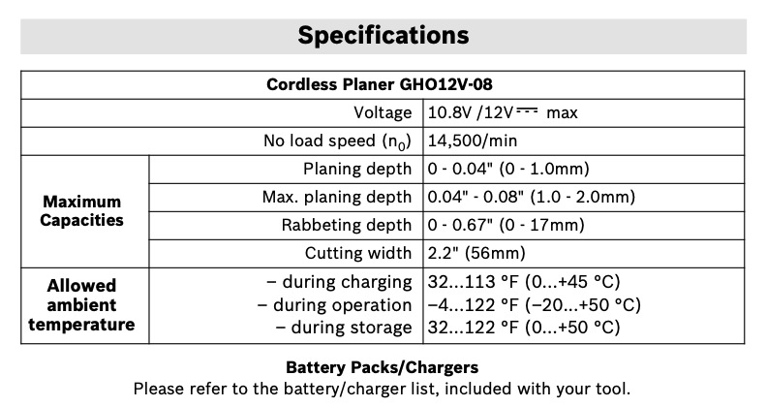

Technical data from website:

## **TECHNICAL DATA**

|  |  |
| --- | --- |
| Battery | Lithium-Ion Battery |
| Battery Chemistry | Lithium Ion |
| Height in | 4.33 " |
| Length in | 10.04 " |
| No Load RPM | 14,500 |
| Planing Depth | 0" - .08" |
| Planing Width | 0" - 2.2" |
| Variable Speed | No |
| Weight | 3.3 lb |
| Width in | 3.94 " |
| Works With | Anti-Static Vacuum Hoses, VH1635A (by means of anti-static adapter included with that hose), VAC008, and most other 35 mm anti-static hoses, Other Vacuum Hoses, VH1035 and VH1635 (by means of VX120 adapter included with those hoses), VAC005 and VAC006 hoses, and most other 35 mm hoses, Adapter for 1-1/4 in. or 1-1/2 in. Hose, VAC024 (incompatible with VAC002) |
| Includes | (1) GHO12V-08 12V Max Brushless Planer  (2) PA1208 2.2 In. (56 mm) Woodrazor Micrograin Carbide Planer Blades  (1) Blade Wrench (1907950003)  (1) Shavings Deflector (1607000CJ0)  (1) Shavings Bag (2605411243)  (1) Vacuum Hose Adapter (1600A012LX) |

**GHO18V-26N PROFESSIONAL (Planers)**

From user manual:

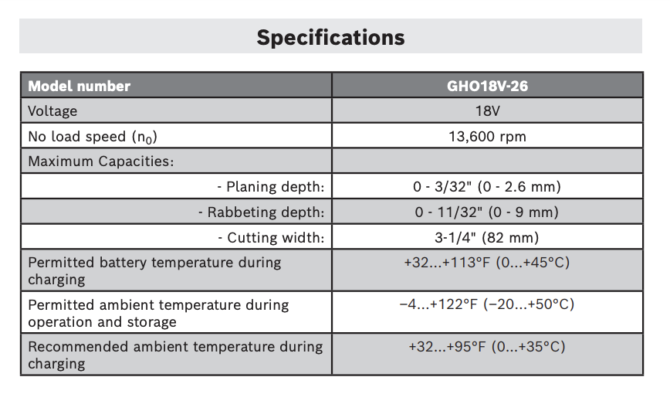

Technical data from website:

## **TECHNICAL DATA**

|  |  |
| --- | --- |
| Battery | Lithium-Ion Battery |
| Height in | 7.3 " |
| Length in | 11.4 " |
| No Load RPM | 13,600 |
| Planing Depth | 0” - 0.102” |
| Planing Width | 0" - 3.25" |
| Variable Speed | Yes |
| Weight | 5.4 lb |
| Weight (lbs.) | 5.4 |
| Width in | 6 " |
| Works With | Shavings Bag, 2605411035, Anti-Static Vacuum Hoses, VH1635A (by means of anti-static adapter included with that hose). VAC008, and most other 35 mm anti-static hoses., Other Vacuum Hoses, VH1035 and VH1635 (by means of VX120 adapter included with those hoses). VAC005 and VAC006 hoses, and most other 35 mm hoses., Adapter for 1-1/4 in. and 1-1/2 in. Vacuum Hoses, VAC002, Adapter For 2-1/2 in. Vacuum Hoses, VAC020, Rabbeting Depth Stop, 2607000073, 3-1/4 Woodrazor Micrograin Planer Blades, PA1202 |
| Includes | (1) GHO18V-26N 18V Brushless Planer (1) Dust bag (1) Guide fence (2) Tungsten carbide blades (one blade installed on the tool and the second blade in the on-tool storage) |

**GTH18V-18MN PROFESSIONAL**

**(Bare Tool)**

From user manual:

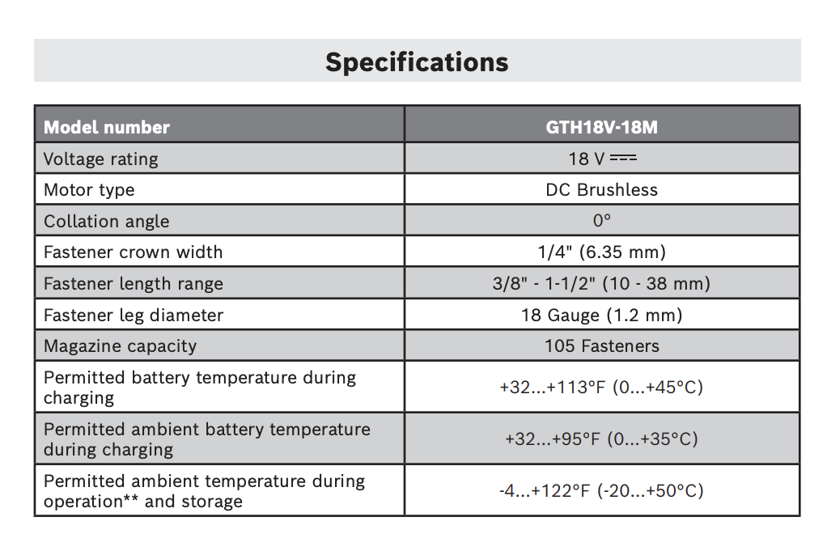

Technical data from website:

## **TECHNICAL DATA**

|  |  |
| --- | --- |
| Height in | 10.9 " |
| Length in | 13 " |
| Weight | 6.8 lb |
| Width in | 3.8 " |
| Works With | GTH18G062GV, 5/8" 18g Narrow Crown Staples - Galvanized, GTH18G100GV, 1" 18g Narrow Crown Staples - Galvanized, GTH18G116GV, 1-3/16" 18g Narrow Crown Staples - Galvanized, GTH18G137GV, 1-3/8" 18g Narrow Crown Staples - Galvanized, GTH18G150GV, 1-1/2" 18g Narrow Crown Staples - Galvanized |
| Includes | (1) Bosch GTH18V-18M 18V Brushless 18-gauge Narrow Crown Stapler |

**GSR18V-755CB25 PROFESSIONAL**

**(CORDLESS DRILL/DRIVERS)**

From user manual:

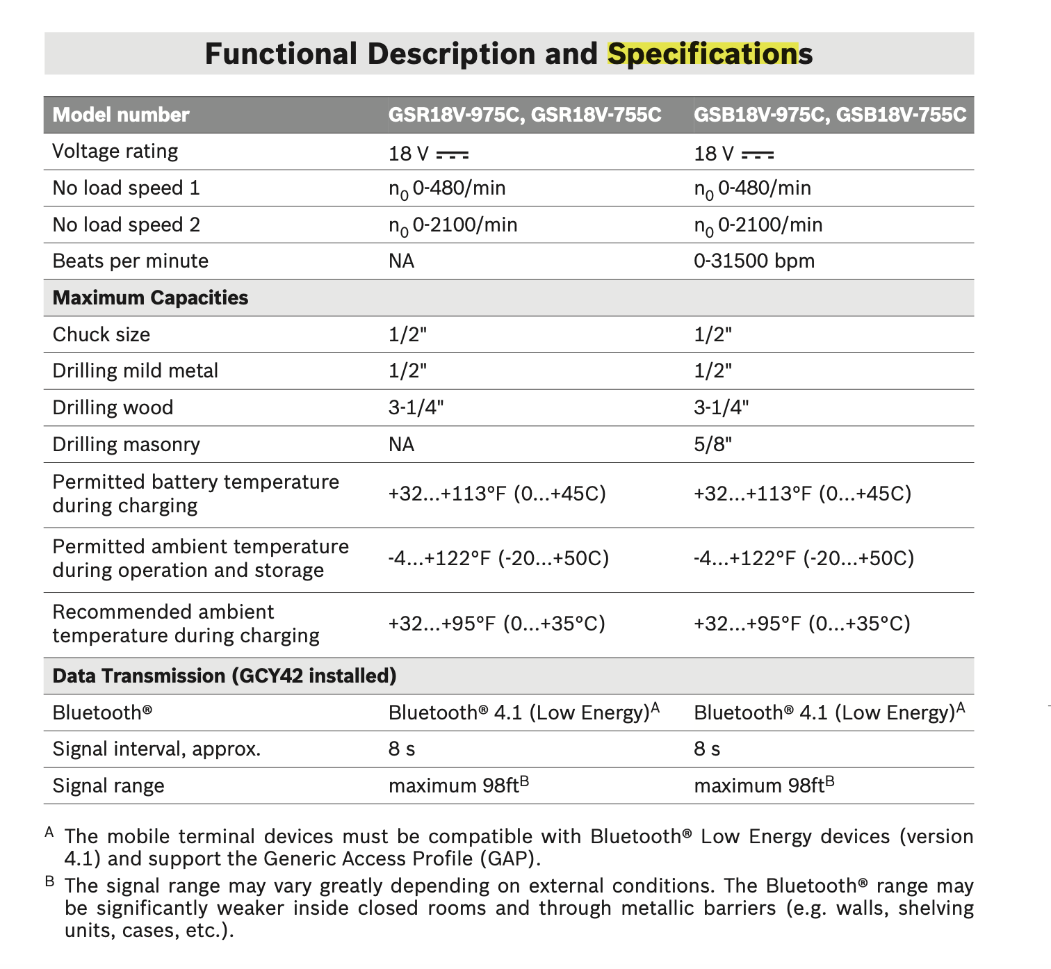

Technical data from website:

## **TECHNICAL DATA**

|  |  |
| --- | --- |
| Battery Chemistry | Lithium Ion |
| Battery/Charger | Included |
| Case Type | Bag |
| Chuck Capacity | 1/2" Keyless Chuck |
| Chuck Design | Keyless |
| Chuck Size | 1/2 in |
| Height in | 8.4 " |
| Length in | 7.6 " |
| No Load RPM | 0-2,100 |
| Reverse | Yes |
| Torque (in. lbs.) | 755 |
| Variable Speed | Yes |
| Weight (lbs.) | 3.4 |
| Width in | 3 " |
| Works With | Bosch Bluetooth® Connectivity Module, GCY42 (See tool manual for its connectivity/app features.) |
| Includes | (1) GSR18V-755C 18V EC Brushless Connected-Ready Brute Tough 1/2 In. Drill/Driver (2) 18V CORE18V Lithium-Ion 4.0 Ah Compact Batteries (1) 18V Charger (1) Auxiliary Handle (1) 4x Bit Holder (4) Bits (1) Belt Clip (1) Carrying Bag |

**GNH18V-16MAN PROFESSIONAL**

**(Nailer)**

From user manual:

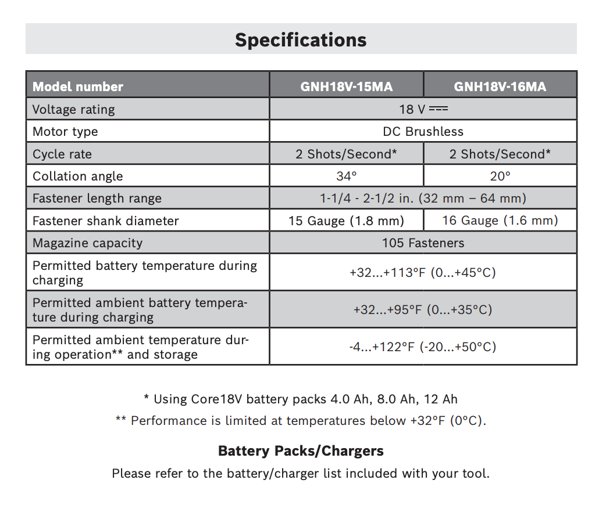

Technical data from website:

## **TECHNICAL DATA**

|  |  |
| --- | --- |
| Height in | 11.1 " |
| Length in | 13.3 " |
| Weight | 6.6 lb |
| Width in | 3.8 " |
| Works With | GNH18G200GV, 1-1/2" 20° 16 ga Finish Nails – Galvanized, GNH16G175GV, 1-3/4" 20° 16 ga Finish Nails – Galvanized, GNH16G200GV, 2" 20° 16 ga Finish Nails – Galvanized, GNH16G225GV, 2-1/4" 20° 16 ga Finish Nails – Galvanized, GNH16G250GV, 2-1/2" 20° 16 ga Finish Nails – Galvanized, GNH16G125GV, 1-1/4" 20° 16 ga Finish Nails – Galvanized |
| Includes | (1) Bosch GNH18V-16MA 18V Brushless 16-gauge Angled Finish Nailer |

**GBL18V-450N PROFESSIONAL**

**(Blower)**

From user manual:

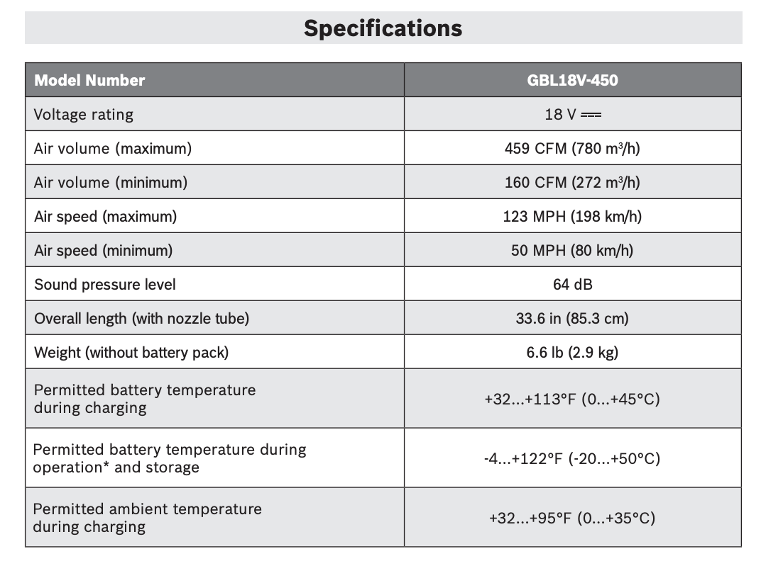

Technical data from website:

## **TECHNICAL DATA**

|  |  |
| --- | --- |
| Air Velocity (mph) | 123 |
| Air Volume (CFM) | 459 |
| Battery Capacity Warning Lamp | No |
| Battery Chemistry | Lithium Ion |
| Decibel Rating (dB) | 64 |
| Height in | 11.9 " |
| Length in | 33.6 " |
| Motor Speed | Variable |
| No Load RPM | 8,000-20,800 |
| Overheat Protection | Yes |
| Overload Protection | Yes |
| Vacuum Capable | No |
| Variable Speed | Yes |
| Weight | 6.6 lb |
| Weight (lbs.) | 6.6 |
| Width in | 7.7 " |
| Works With | Recommended Battery Packs to help achieve maximum tool performance, GBA18V80 and GBA18V120 Batteries |
| Includes | (1) GBL18V-450N PROFACTOR™ 18V Blower |